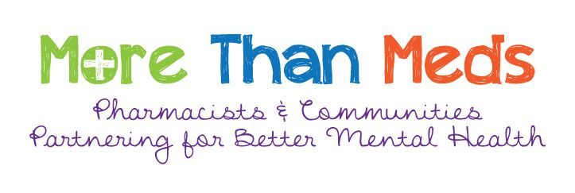
Outreach Public Education/Support Session Feedback
Thank you for coming to our session.

Please take a moment to give us your feedback. You do not have to do this but it would help us know if the session was helpful or not. You can use this form or you can complete the feedback online at www.morethanmeds.com. Just click on the “Rate our education session!” button on the main page.

Date: | Where was the session?

Please check all that apply:
with lived experience of mental illness
who cares for someone with lived experience of mental illness
who is interested in this information
I am a person

This session was led by:
a pharmacist and a person with lived experience of mental illness (or a caregiver)
a pharmacist
other – please tell us who gave the session: _______________________________

How did you find out about today’s session?

What did you like about the session?

How could we make the session better?

What did you get out of today’s session?

Should we offer sessions like this again? |  |  |  | Would you recommend this session to others?
 | Yes |  |  |  | Yes
 | No |  |  |  | No
 | I don’t know |  |  |  | I don’t know

Other comments:

